Group Members: Tiraj Parikh, Nicolai Antonov, Akshata Sastry

**Application Name:** GlucoImager

**Application Description:**

Currently, there exists a colorimetric assay which changes color based on glucose concentration, used by diabetics in measuring blood glucose level. However, this color change is poorly recognized by the naked eye, and is hence very inaccurate.

Our application idea is an iPhone 6s application which takes a picture of this colorimetric assay, then uses image processing to analyze the picture in order to output a more accurate and precise blood glucose reading. Additionally, this application will allow the user to make an account which stores the glucose readings taken over time, indicating the trend over a period of time.

**Description:**

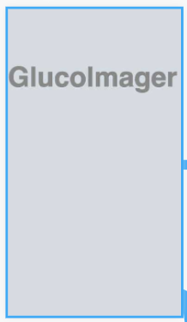

When the application is open the logo with pop up. This will introduce the user to the application through a splash screen.

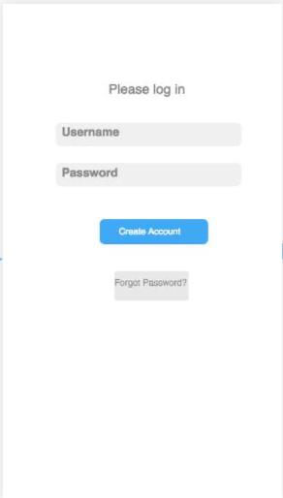

The splash screen will fade and reveal the login screen. If the user already has an account, then they can go ahead and log into the app, pressing “Done” on the keyboard to indicate completion. If the user forgets their password, then they can click the “Forgot Password?” button. If the user doesn’t have an account, then they can click the “Create Account” button.

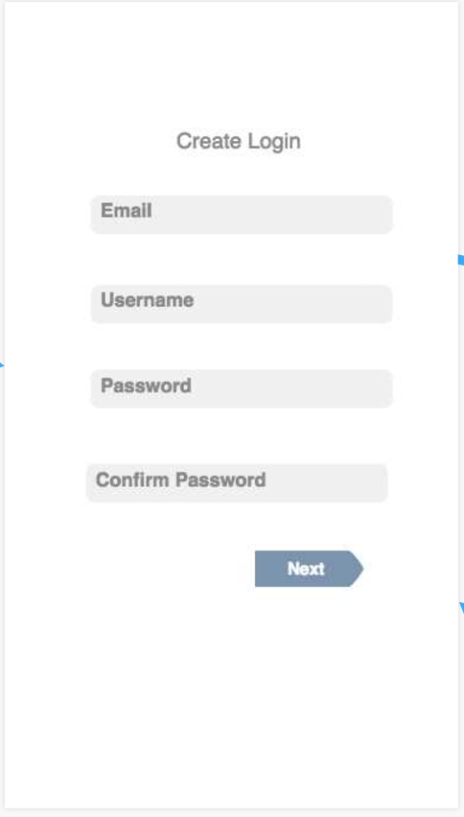

If the user clicks the “Create Account” button, it will take then to another screen with text fields for them to enter their email, username, password, and confirm password. When they are finished they can click the next button at the bottom of the screen.

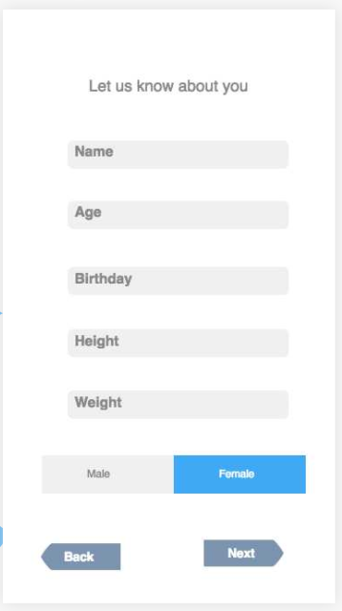

Once they have moved past this screen, they will be prompted to customize their profile. To create a profile we will need some information from the user. They will be asked to enter their name, age, gender, birthday, height, and weight to complete their profile. The user clicks the next button at the bottom when they are done. If the account is created successfully, then the user will be taken to their profile.

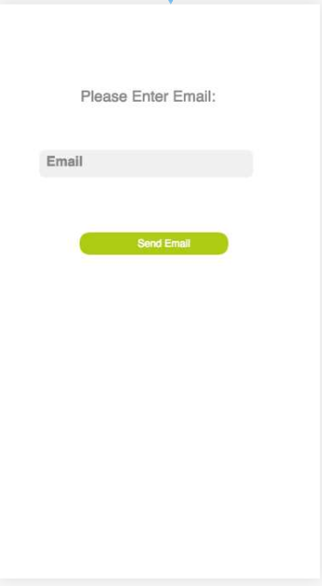

If the user chooses to click the forget password button, then it will take them to a screen where they can enter their email address. Once they enter the email associated with their account, they will be sent an email with a random password which they can use to get into the application, and will return them to the splash screen.

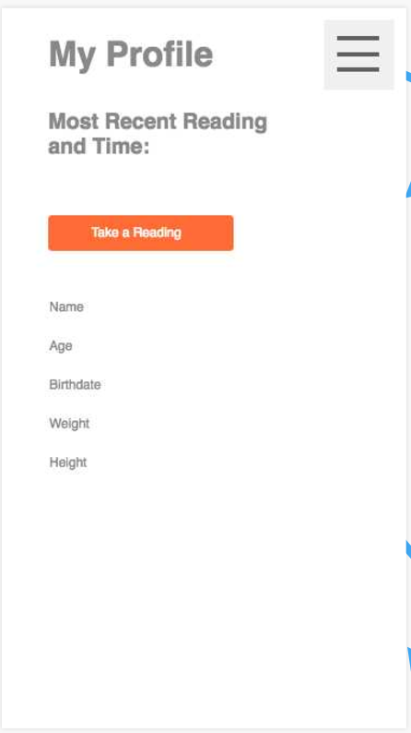

The user’s “My Profile” page contains the most recent blood glucose reading, the user’s information they added previously, a settings bar on the side, and a button to check blood glucose level.

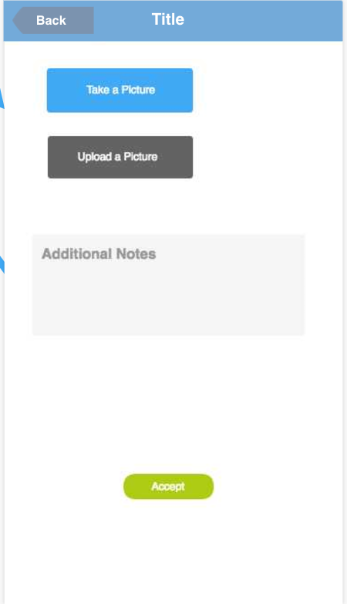

If the user presses the button to check their glucose level, a new screen will show up that prompts them to take a picture (which will open the camera) upload a picture (which will open the gallery), and to write any additional notes regarding any irregularities with their measurement. When the user presses “accept” this data will be stored along with the time of measurement and the notes, and can be seen in the “History” page under settings.

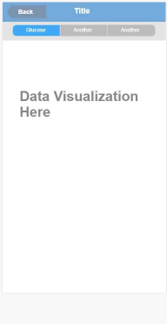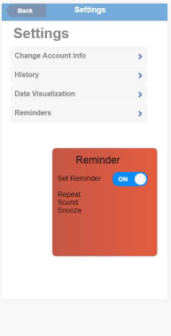

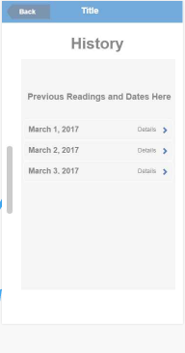

The settings menu allows the user to change account information, view their history, view data visualizations, and reminders.

* If they would like to change account information, they will be taken back to the enter username and password page.
* If they press “History” they will be taken to a page with a list of all previous records and their dates/times, and if they click on a specific record a popup will appear with the additional notes they added on that date.
* If they press “Reminders” a popup (represented as the red box) will appear prompting them to turn off or on push notifications which will appear based on frequency set in that popup window.
* Finally, the “Data Visualization” button will allow the user to see glucose trends over different spans in time as a scatterplot.

**Full Interface:**